.✠

## PRAYER REQUESTS

Family of Janet Scragg

Angel and newborn daughter,

Nellie Sue Dawn Lelaikes

Joan Leslie Evans Bissett

Debbie Bernard

Nancy Wolfe

William Steele

Mary Landers

Shannon Guensch

Jeremy Johnson

Eugene King

Greg and Lori Carpenter

David Johnson

Matt Wazelle

Karen Johnston

*These names will be moved to

our on-going prayer list after two weeks.

your grace, your strength and your wisdom to sustain and guide

us, or else we will fail. So, we seek your help, asking that you

would be with us always to order and direct our lives. **Amen**

**ANTHEM** “No Tears Tomorrow”

**SCRIPTURE**  “Jeremiah 17:5-10” **George Hohmann**

**THE MESSAGE** “Junking Our ‘Junk’” **Pastor Dave Biondi**

**JOYS & CONCERNS**

**PRAYERS OF THE PEOPLE**

**RESPONSE**  ”Turn Your Eyes Upon Jesus” **UMH #349**

**THE GIVING OF OUR GIFTS**

**THE OFFERTORY** “Give Thanks”

\***THE DOXOLOGY “**Praise God, from Whom All Blessings Flow”

**UMH #94**

**THE PRAYER OF DEDICATION**

**\*THE SENDING HYMN** “Take My Life, and Let It Be”

**UMH #399**

**\*THE BENEDICTION**

**\*CONGREGATIONAL RESPONSE “Go In Peace”**

Go in peace and the peace of God

Be with you this day.

Go in peace and the peace of God

Be with you always.

Celebrate and share the joy!

Celebrate new life!

Go in peace and the peace of God

Be with you always.

**POSTLUDE**  “Marching to Zion”

*Invites Congregation to Stand

.

**FIRST UNITED METHODIST CHURCH**

*Sixth Sunday after the Epiphany, February 17, 2019*

**WE GATHER TO WORSHIP GOD**

**ANNOUNCEMENTS**

# THE PRELUDE “Seek Ye First”

# 

# THE LIGHTING OF THE ALTAR CANDLES

# 

**GOOD NEWS FOR CHILDREN Carrie Hamilton**

**CHILDREN'S WORSHIP**

Children age three and under may go to the nursery

Children age four through 6th grade (2nd floor)

**\*CALL TO WORSHIP**

**Leader:** We are the people of God, gathered together so that we

might worship and glorify the Lord.

**People: We want to be here so that we can seek the Lord’s**

**will and support one another in our pilgrimage.**

**Leader:** We want to be here because Christ’s Holy Church is

God’s gift to enable us to grow in faith and love.

**People: If we are here for any lesser reason, O Lord, turn**

**our hearts more fully to you this day. Amen**

**\*THE HYMN OF PRAISE** “Joyful, Joyful, We Adore Thee”

**UMH #89**

\***CONGREGATIONAL PRAYER:**

Almighty and most merciful God, all too often we have acted

to please ourselves rather than acting to please you. As a result,

we have filled our lives with all kinds of “junk” that has served

to turn our hearts away from you. Forgive us, O Lord, we pray,

for you must be the highest priority of our lives. We must live for

you alone, so that everything we do would be to your glory. This

ideal, O Lord, is difficult for us to achieve; therefore, we need

Our ancestors in the faith dared to trust God;

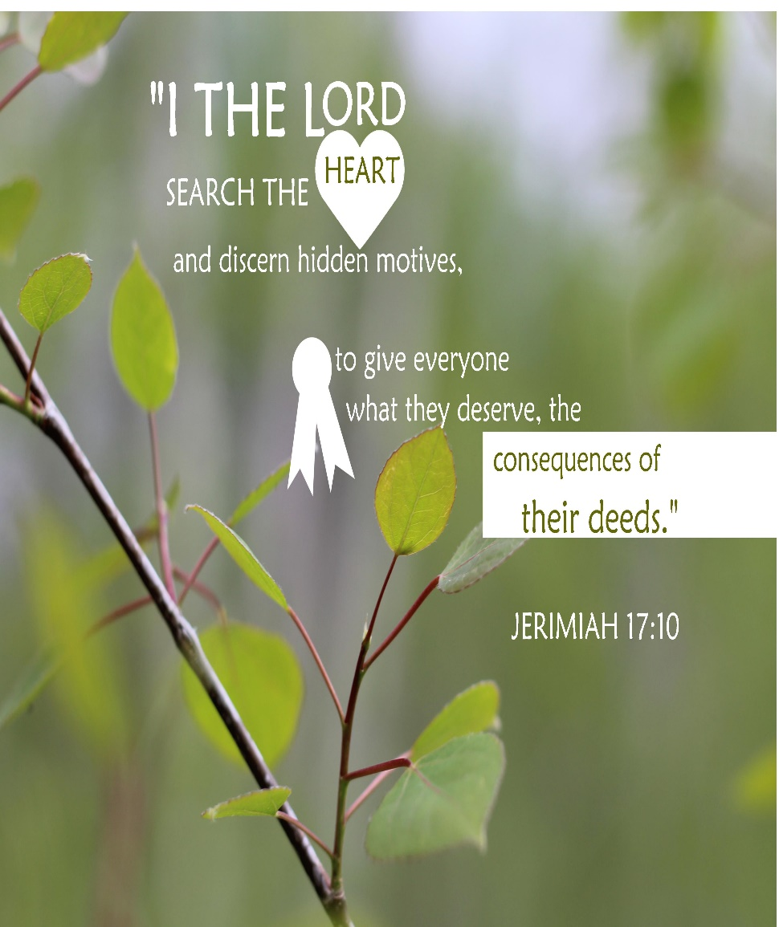

**What Is Happening This Week at First Church**

**SUN:** 9:45 AM Sunday School

11:00 AM Worship

UM Youth will not meet

**MON:** Church Office Closed for President’s Day

5:00 PM Zumba

7:00 PM Boy Scouts in Scout Room

**TUES:** 5:00 PM Zumba

6:00 PM TOPS

6:45 PM Cub Scouts in Scout Room

6:45 PM South Ridge Lions Club in Social Hall

**WED**: 5:30 PM WOW!

**THUR:** 5:00PM Zumba

7:00 PM Choir Rehearsal

**FRI: Church Office Closed**

5:00 PM Community Dinner in Social Hall

**SAT**: 2:00 – 4:00 PM Social Hall reserved

**SUN:** 9:45 AM Sunday School

11:00 AM Worship

5:30 PM UM Youth in Youth Room



To the Glory of God and in loving memory of Asher Paul Spurlock’s

10th birthday (2/20), grandson of Kathy Parsons.

*First United Methodist Church*

*905 Glendale Avenue, South Charleston, 25303*

email: **fumcsc@frontier.com** - ph. 304-744-3211

Pastor Paul's cell phone #304-695-0013

email: [wvpastorpaul@gmail.com](mailto:wvpastorpaul@gmail.com)

website: southcharlestonfirstumc.org

*Morning Worship*

*February 17, 2019*

*Pastor Paul Helmick*

*First United Methodist Church*

*South Charleston*

**Ministry of Worship**

**The Ushers:** Jim Snyder, Danny

Murphy, George Russell, Larry Wolfe,

Roy, Spencer and Taylor Fultineer, Bob

Judge, Andrew Byrd, Jerry, Wesley,

Cody Buckley, Don Barnard and

Gary Anderson

**Acolytes**: Rachel Bostic, Lillian

Hamilton, Reagan McLeary and

Amaya Young

**Christian Education Director:**

Carrie Hamilton

**Next** **WOW: February 20, 2019**

**Director of Music:** William Holbrook

**Administrative Assistant:** Linda Nehr

Deadlinefor submitting items for

Sunday Worship bulletin is

**Noon on Wednesday.**

**Custodian**: Janice Pauley

**Tape Ministry:** Don Ryan, Gary Good,

Ed King and Mike Cidor

**Tech Today: Kathy Parsons**

February 24: Sara Hampton

**N**ewsletter: Barbara Brown

[c](mailto:Cbpnuts@aol.com)bpnuts@aol.com

Articles due monthly on the 20th

**Please remember** to sign the registration pad located in the side of the pew.

Please greet our visitors and pass the registration pad to them.



**Danny and I have so much to be thankful** for during his surgery and recuperation. He has received so many get well and birthday cards, flowers from the church, visits to the hospital and nursing home, Dave Biondi’s prayer before Danny went to surgery, the camouflage prayer shawl, food brought to me and meals taken to Danny, the phone calls to check on him and me, prayers and well wishes from so many people. Our church family is a blessing and have been

so good to Danny and me.

**Sally Adkins would like to thank** everyone for the visits, cards, and food

during her recent illness. The prayer shawl kept her warm and safe during this time. Sally plans to be in church very soon. Thanks again.

**The rose bud** on the altar is for the birth of Nellie Sue Dawn Lelaikes, great granddaughter of Art and Nancy Altman. Nellie was born on

Wednesday, February 6.



**Mark your calendar** for Friday, February 22, for the next Community Dinner in the Social Hall at 5:00 p.m. Join your church family and community friends for

a delicious meal prepared by United Methodist Men. They will be serving spaghetti with meat sauce, salad/dressing, bread, desserts and drinks. Hope to

see you at the dinner!

**The women’s small group**, Faithful Friends, will be meeting in the parlor on Thursday, February 28, at 6:30 p.m.

**We will no longer** take egg cartons for Heart and Hand. Heart and Hand

advises they do not need egg cartons at this time. Thank you for your past donations of egg cartons

**ARE YOU A WOMAN?**

Do you want to fellowship, to praise, AND to grow in the knowledge of JESUS?

Plan on attending United Methodist Women’s 2019 SPIRITUAL GROWTH EVENT! This two-day event (Friday, March 22, 2019 and Saturday, March 23, 2019) will be held at Cedars Lakes Conference Center, Ripley, West Virginia!

Spiritually uplifting music by Morris Memorial Praise Band!

Registration forms are available in the Narthex or church office. If you have

any questions or need more details, please contact Sharon Byrd (home 304-744-6219 or cell-text 304-549-6129 or email disabyrd@suddenlink.net).

**FUMC Tech team wants to grow!**

Join the team to help keep the slides moving on Sunday mornings. No special training required, just the willingness to serve for one hour on some Sunday mornings. If you would like to be a part of this group, please contact Kathy Helmick at 304-695-0014 or email kathyjaneh@gmail.com

**First Church** continues to offer its Snow Day Program this winter! We provide free childcare from 8:00 a.m. to 3:00 p.m. and serve breakfast and lunch on days when school is cancelled due to inclement weather. Please contact Sara Hampton (304-545-8398) if you can volunteer to help with the children or prepare lunch

on snow days. Thank you.

. 

**Altar Flowers Open Dates: March 24 and 31, April 21, 28, May 5, 26,**

**June 2, 23, and 30 2019.**  Please call the church office ifyou would like to

place flowers on the altar. The cost is $30.00.