.

PRAYER REQUESTS

Norma McDowell
Lissa, Michael, Haley
and Austin Jordan
Bill Adamson
Jennifer Grady
Linda Johnson
John Carter
Glenna Wells and family
Dreama Clark
Annabella Tiano
Robbie Haynes
Morgan Mascherino & Emerson
Skip Gillespie
Hazel Childress
Cathy Batten
Gary Colb
Amanda Walton
Tom and Sue Hall

*These names will be moved to
our on-going prayer list after two weeks.

SCRIPTURE “Revelation 21: 1-6a” Jeanne Murphy

ANTHEM “Song of the Saints”

THE MESSAGE “Hope” Pastor Paul

JOYS & CONCERNS
PRAYERS OF THE PEOPLE
RESPONSE ”Turn Your Eyes Upon Jesus” UMH #349

THE GIVING OF OUR GIFTS
THE OFFERTORY “With Reverence Let the Saints Appear”
*THE DOXOLOGY “Praise God, from Whom All Blessings Flow”
UMH #94
THE PRAYER OF DEDICATION

A SERVICE OF WORD AND TABLE
A TIME OF REMEMBRANCE “The Naming of the Honored Dead”
(As the names are read, you are invited to stand in tribute and
homage of anyone with whom you should happen to feel a
special connection)
*THE SENDING HYMN “Soon and Very Soon” UMH #706

*BENEDICTION “Go In Peace”
Go in peace and the peace of God
Be with you this day.
Go in peace and the peace of God
Be with you always.
Celebrate and share the joy!
Celebrate new life!
Go in peace and the peace of God
Be with you always.

POSTLUDE “Praise Our God”

.

FIRST UNITED METHODIST CHURCH
Twenty Fourth Sunday after Pentecost, November 4, 2018
WE GATHER TO WORSHIP GOD
All Saints’ Day

ANNOUNCEMENTS

THE PRELUDE “I Will Arise and Go to Jesus”

THE LIGHTING OF THE ALTAR CANDLES

GOOD NEWS FOR CHILDREN Carrie Hamilton
CHILDREN'S WORSHIP
Children age three and under may go to the nursery
Children age four through 6th grade (2nd floor)

*CALL TO WORSHIP
Leader: I looked over Jordan, that river we all will eventually cross…
People: O Lord, what a vision.
Leader: I could see the saints singing and dancing.
I saw grandpa fishing in the Crystal Sea.
I heard grandma humming in the kitchen…
People: O Lord, what a vision.
Leader: There were countless others, all faithful disciples,
gathered worshiping…
That old man who sang solos in the choir,
That young man whose life was cut short in that accident…
People: O Lord what a vision.
Leader: But the most amazing thing I saw as I looked over Jordan…
People: Yes? Yes?
Leader: Was the man standing in the shallows, smiling, saying
People: “Welcome Home”.

*THE HYMN OF PRAISE “For All the Saints” UMH #711
Verses 1, 3, 4

*CONGREGATIONAL PRAYER Words on Screen

Our ancestors in the faith dared to trust God;

Ministry of Worship

The Ushers: Jim Snyder, Barney Lilly,
Danny Murphy, George Russell,
Larry Wolfe, Roy, Spencer and
Taylor Fultineer, Bob Judge,
Andrew Byrd, Jerry, Wesley, Cody
Buckley and Gary Anderson
Acolytes: Rachel Bostic, Lillian Hamilton,
Reagan McLeary and Amaya Young
Christian Education Director:
Carrie Hamilton
Next WOW: November 07, 2018
Director of Music: William Holbrook
Administrative Assistant: Linda Nehr
Deadline for submitting items for
Sunday Worship bulletin is
Noon on Wednesday.
Custodian: Janice Pauley
Tape Ministry: Don Ryan, Gary Good,
Ed King and Mike Cidor
Nursery/Toddler: (For infants through
age 3) Volunteers:

Tech Today: Sara Hampson
November 11, 2018: Mike Cidor
November 18, 2018: Greg Young
November 25, 2018: Kathy Parsons

Newsletter: Barbara Brown
cbpnuts@aol.com
Articles due monthly on the 20th

Please remember to sign the registration pad located in the side of the pew.
Please greet our visitors and pass the registration pad to them.

What Is Happening This Week at First Church

SUN: 9:45 AM Sunday School
11:00 AM Worship
3:00 PM Charge Conference at
St. Paul’s UM Church in Nitro
5:00 PM Financial Peace Class in social hall
5:30 PM UM Youth in youth room
MON: 5:00 PM Zumba in social hall
7:00 PM Boy Scouts in scout room
TUES: 6:30 AM – 7:30 PM General election in social hall
10:00 AM Men’s small group meeting
in parlor
5:00 PM Zumba in youth room
6:00 PM TOPS
Cub Scouts will not meet
WED: 5:30 PM WOW! in social hall
THUR: 5:00 PM Zumba in social hall
7:00 PM Chancel Choir
FRI: Church Office Closed
SUN: 9:45 AM Sunday School
11:00 AM Worship
5:00 PM Financial Peace Class in social hall
5:30 PM UM Youth in youth room

To the Glory of God and in memory of Wilhelmina Nehr, by
Bill and Linda Nehr.

First United Methodist Church
905 Glendale Avenue, South Charleston, 25303
email: fumcsc@frontier.com - ph. 304-744-3211
Pastor Paul's cell phone #304-695-0013
email: wvpastorpaul@gmail.com
website: southcharlestonfirstumc.org

Morning Worship
November 04, 2018
Pastor Paul Helmick
First United Methodist Church
South Charleston

Conscientious Coins will be received next Sunday, November 11.

Upper Rooms for November/December are available in the Narthex
along with the birthday/anniversary list.

Our November Newsletter was emailed out last week. If you did not receive it, please contact Barbara Brown at 304-542-6197 or cbpnuts@aol.com. Printed copies are in the Narthex. If you would like to receive the newsletter by email, please give Barbara your email address.

Altar Flowers Open Dates
are November 25, December 30. Please call the church office if you
would like to place flowers on the altar. The cost is $30.00.

I would like to thank everyone who has sent me a card, called, and brought food. It has all been soooo appreciated! It’s been a rough 2 weeks and I’m ready to be back to normal, but it’s still going to be a while. I have an appointment with the surgeon on Monday, November 6th, and will most likely receive a cast that day, which will be on between 4 and 6 weeks. Thanks for everything! Holly Murphy

It is that time of the year again to ring bells for Heart and Hand Toy Fund. We will be ringing bells on Monday, November 26, Tuesday, November 27, and Wednesday, November 28, from 10:00 a.m. – 6:00 p.m. at Riverwalk Kroger. A sign-up sheet is on the table in the Narthex. Please help by signing up to ring bells for Heart and Hand Toy Fund.

Poinsettias for Christmas will be placed in the Sanctuary on Sunday,
December 16. If you would like to place a Poinsettia in memory or honor of a loved one or friend, write your request on the registration pad or call the church office by Tuesday, November 27. If you leave a note in the collection plate to order a Poinsettia, please let Linda know to make sure the note is received. The cost is $10 per Poinsettia. Poinsettias will be ordered on Wednesday, November 28, so payment needs to be received in the church office by Tuesday, November 27, as the garden center requires payment at the time the Poinsettias are ordered.

The Pecans have arrived!
The pecan halves are $10.00 for a pound package. Also have brooms for sale for $10.00. See a United Methodist Woman member or call the church office to purchase pecans.

Friends at First Church UMC – Thank you so much for your support of
the Kay Hall Hike for Hunger. Your generosity and time helped to raise over $10,000! These funds will be used to help people in need in our community. You all are Amazing! Patty Tilley, Program Director

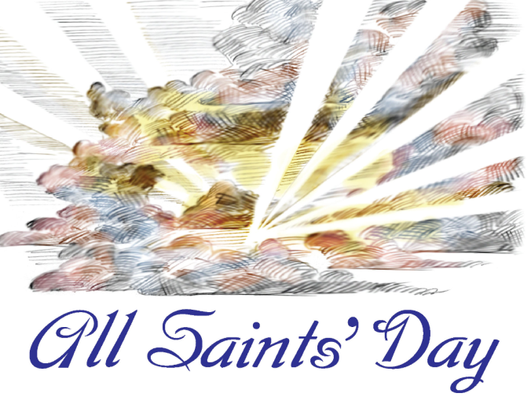
Phyllis Allen
Elinor Bare
Carl Childress
Betty Childress
Sherry Gilkerson
Barbara Harvey
Mary Louise Jackson
Mary Ellen Nuzum
Joe Mayes
Rudy Schwab
Doug Thomas
Ronnie White
Harold Wright

